Name: ________________________

Absolute and Relative Location

Location, one of the five themes of geography, seeks to answer a simple question: “Where is it?” There are two types of location that we have defined: absolute and relative location. An absolute location describes a precise point on Earth or another defined space. A relative location describes where something else by using another, familiar feature as a reference point.

Identify whether the given description describes a relative location (R) or an absolute location (A). Write your response in the blank using capital letters only.

______1. Describing where you go to school, you say: “1170 Carew Street”.
______2. Describing where you go to school, you say: “Down the street from the Walgreens”
______3. Describing where Springfield is, you say: “42° N, 72° W”
______4. Describing where you have Social Studies at VSA, you say “Room 206”
______5. Describing where you sit in social studies class, you say “In the front”

Identify a way to describe the following locations, making sure to respond with absolute or relative locations depending on what the questions asks of you.
6. (absolute) Describing where your house is, you say:
______________________________________________________________________________ 7. (relative) Describing where your Middle School is, you say:
______________________________________________________________________________

For the following situation, decide if absolute location or relative location would be the most helpful. Change the color of your answer. Then, write a complete sentence explaining why you think this is true.

8. You want to locate Harrisburg, a city you have never heard of, on a world map because a friend mentioned they visited there over the summer. The problem is you don’t know the country in which the city is located!

Absolute or relative?

Why?

Part 2
Google Earth Coordinate Scavenger Hunt
Use the supplied coordinate to find interesting things/places around the world using Google Earth.
1) Use Google Chrome and go to https://www.google.com/earth/
2) Click “Launch Earth” (Both options will work)
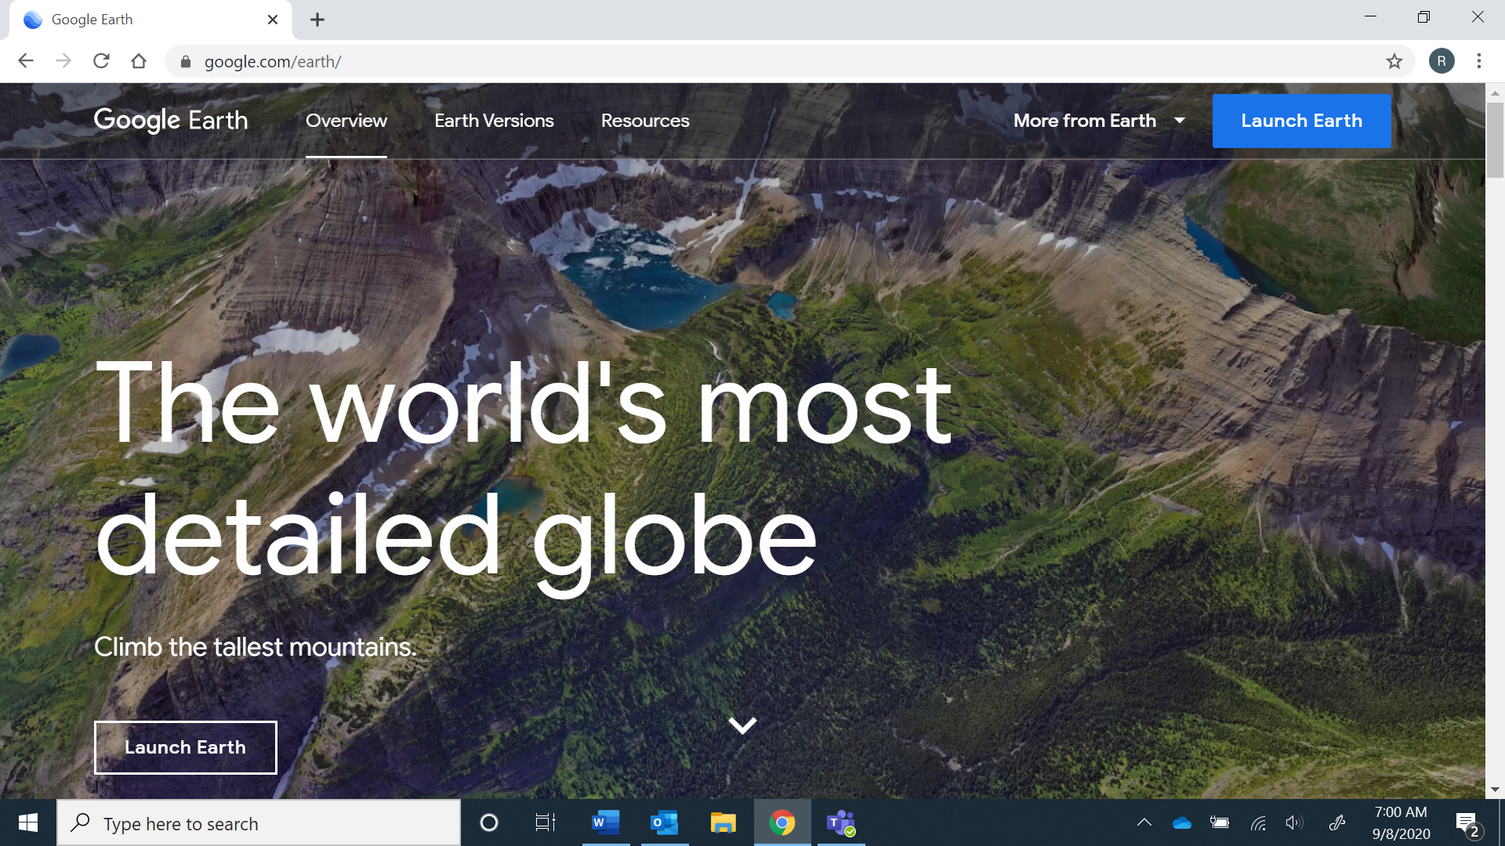
3) After it loads, click on the magnifying glass and enter the coordinates exactly as they are shown- it will then “bring” you to that location, describe what you see! Hint: sometimes you will need to zoom in or out to get a clearer picture of where you are.
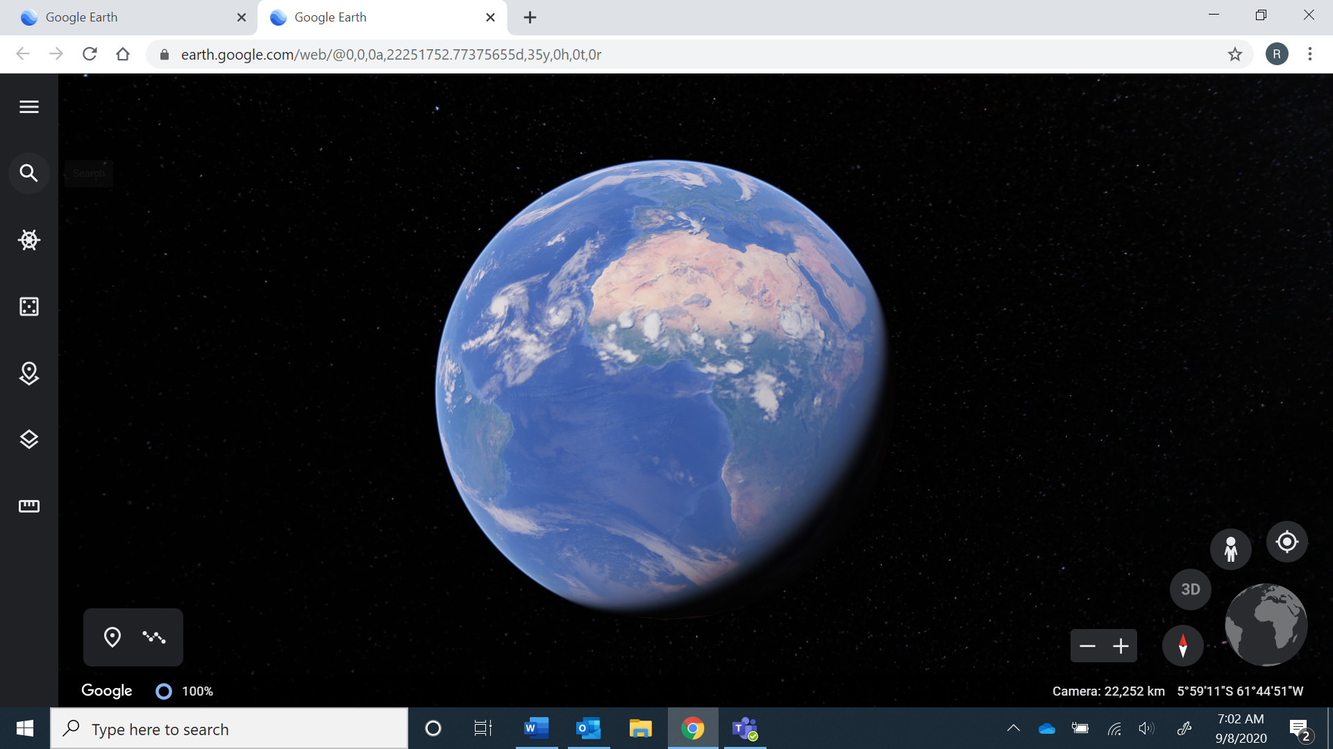

Coordinates | Description
42 08’00”N, 72 34’33”W
42.302284, -83.231215

28 23’46”N, 81 34’42.11”W

33 52’04.4”S, 63 59’13.2”W

26 21’28.4”N, 127 47’01.7”E

